CSS Cascading style sheet

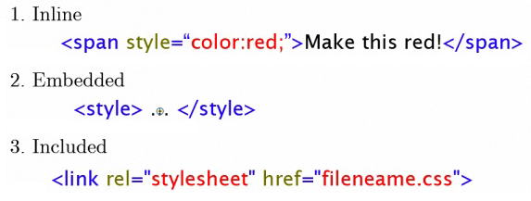

**SELECTORES**

1. **Tag name**
2. **Class**
3. **ID’s**

<html>

<head>

<title> titulo </title>

<style>

p#p2 { color: **blue**; } // By ID **“p2”** inside paragraph **“p”**

.green { color: green; } // By class name “**green**”

</style>

</head>

<body>

<p **id=”p2”**>**By ID, this is in blue** </p>

<p **class=”green”**> **By Class, this is in green** </p>

<p style=”color: red;”>By Tag Name, this is in red <p>

</body>

</html>

**<em> Emphasis </em>**

|  |  |
| --- | --- |
| Class blue is applied to “p” elements only | p.blue { color: blue; } |
| Apply font color purple to the paragraphs inside a div |  |
| Apply font color purple to the emphasis (em) inside a paragraph inside div |  |
| You can assign multiple classes to an element |  |

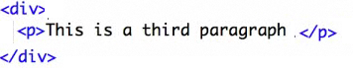

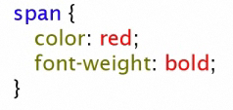

|  |  |
| --- | --- |
|  | Applies to |
| Aplica si tiene span y dentro em |  |
| Aplica tanto para span como para em |  |

**RULE ORDER**

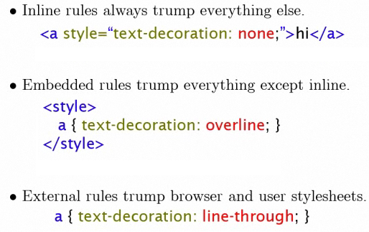

**CONFLICT:**



border: solid 1px #CCC;

border-top: solid 1px #CCC;

border-bottom: solid 1px #CCC;

border-left: solid 1px #CCC;

border-right: solid 1px #CCC;

font-family: Times New Roman;

font-size: 17px

font-style: normal; // italic, oblique, etc

font_weight: normal; // inherit, lighter, bold

letter-spacing: 1px; // space between letters

line-height: 16px;

margin-left: 20%;

margin-right: 20%;

text_align: left; // right, center, justify

text-decoration: none; // blink, line-through overline, underline

text-indent: 0; // only first line is indented

text-shadow: 1px 3px 3px green; // offset up, offset left

text-transform: none; // lowercase, capitalize

word-spacing: 3px // spacing between words

word-wrap: break-word; // normal

text-indent:none;

text-shadow: black 0.1em 0.1em 0.2em;

<http://www.csscompressor.com/>

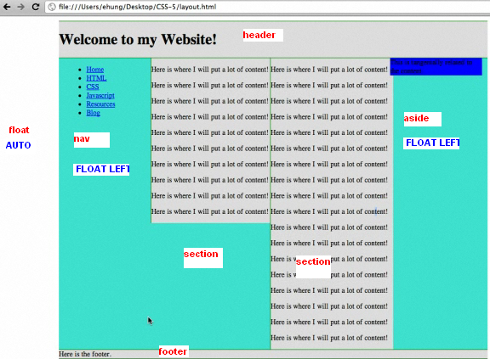

|  |  |
| --- | --- |
| **ALL ARE WITH BORDER, SOLID, DISPLAY, AND COLOR** |  |
| THE WHOLE CONTAINER IS TURQUOISE (GREEN AQUA), AND HAVE AUTO FLOAT TO THE RIGHT AND LEFT  WIDTH 700 TO CONTENT: NAV, 2 SECTIONS, ASIDE |  |
| **HEADER AND FOOTER WIDE** |  |
| **FOOTER, AVOID THE FLOAT FROM PREVIOUS SECTIONS** |  |
| **NAV, WITH AND FLOAT TO THE LEFT, DRAW BORDER RIGHT GREEN (150 FROM 700 OF THE DIV)** |  |

**IT WILL NOT SHOW INDENTATION , ONLY THE FIRST OPTIONS IN NAV**

-1

-1.2

-1.2.1

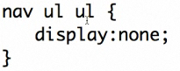

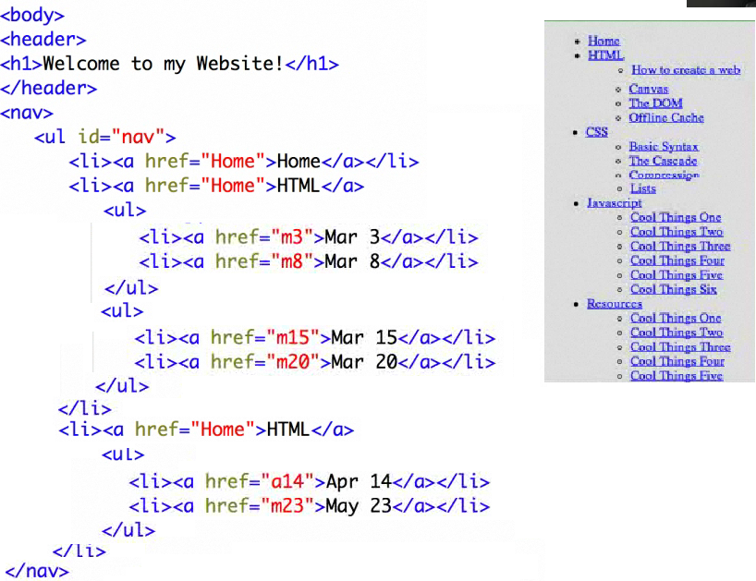

**IT IS GOING TO BE 2 SECTIONS TO CREATE 2 COLUMNS (OVERFLOW: HIDDEN)**

<section>

</section>

<section>

</section>

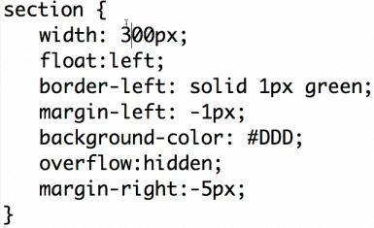

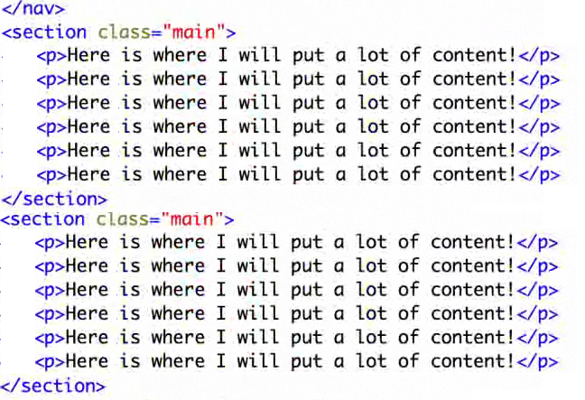

ASIDE: WIDHT 150 FROM 700, IT IS GOING TO BE BLUE, FLOAT LEFT

